# Introduction to the Math-Games Project

***Using games to develop numeracy***

*Games can help learners to practice matching, counting and computational skills such as doubling, addition, subtraction and tables. Some games combine these skills with strategy, and this can help learners to develop problem-solving skills. Children’s boards’ games or dominoes can be used in family numeracy sessions. Adult games include bingo, dominoes, card games, strategy games such as backgammon, and traditional African games such as Oware and Ayo, which are now available commercially.*

*Statement from the “Adult Numeracy Core Curriculum”, London, 2001*

More than 13% of all people in Europe cannot read, write or count. Therefore it is the declared goal of the European Union to remedy this situation and to reduce the number of poorly trained people. The project Math-GAMES has been developed within this environment; its title says it all: *"****Math Games - Games and Mathematics in Education for Adults - Compendium, Guidelines and Courses for Numeracy Learning Methods Based on Games******(Mathematical Literacy)”.*** In the project books and hand-outs will be created, such as the present compendium together with the guidebook, which should give an answer in nine languages to the following questions:

1. How can we reduce the number of under skilled adults to promote social integration and participation into our society?
2. How can we increase incentives for adult training by using games?
3. How can we offer tailored learning opportunities to individual learners by using games?
4. How can we provide information on accessing to the services of adult learning?
5. How can we save traditional and famous games in different countries from being lost?

**The Math-GAMES Project will give the following answers:**

To 1: We can reduce the number of under skilled adults to promote social integration and participation into our society by giving them the opportunity to learn what they need in their jobs or in other fields of their life. Many people do not want to admit that they have deficits in the area of reading, writing and arithmetic. The result is a retreat from social life. By renewing and refreshing the knowledge people get self-confidence and find better their place in society. This refreshing and renewing of lost knowledge takes place through hands-on learning in a group, without coercion, but with a lot of fun. The recovered confidence and fun in a group allows many people to participate in society again.

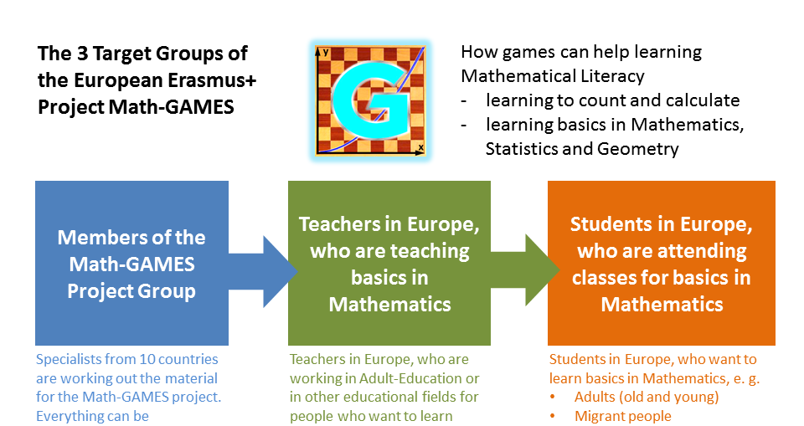To 2: We can increase the incentives for adults because we use games that are fun and can be played without much knowledge of every human being. The combination of games and the subsequent learning motivation is increased to deal with a subject matter, which one would not normally do. So that is the motivating feature of gambling is exploited in order to learn a difficult subject matter.

To 3: We can offer tailored learning opportunities to individual learners through games, in such a way that we appropriately choose the games to the participants. It can be dealt with cultural differences as well as differences in learning behaviour and knowledge. E.g. if we have a group of adult migrants from Arabia, people can be reached by Tafli game faster than with a card game which is unknown. We can also choose to watch so that mathematical knowledge is targeted, such as accurate identification of numbers between 1 and 6 at dice. But for instance, if a group wants to learn everything for commercial arithmetic, we can support learning with fun and enjoying the game "Monopoly".

To 4: We can provide information on accessing to the services of adult education by creating a low input threshold so that everyone loses his inhibitions to attend courses for adults. By announcing that it is a class with games participants will come who would otherwise never visit a mathematical course.

To 5: In different countries we can protect traditional and popular games from being lost, because we use only those games that are known and are used by many people. This helps to save the game from extinction, because many people only play with electronic devices and no longer traditional games. Moreover, these games are more suitable for learning, as the social component is larger and provides more fun.

## Structure of the European Erasmus+ Project Math-GAMES

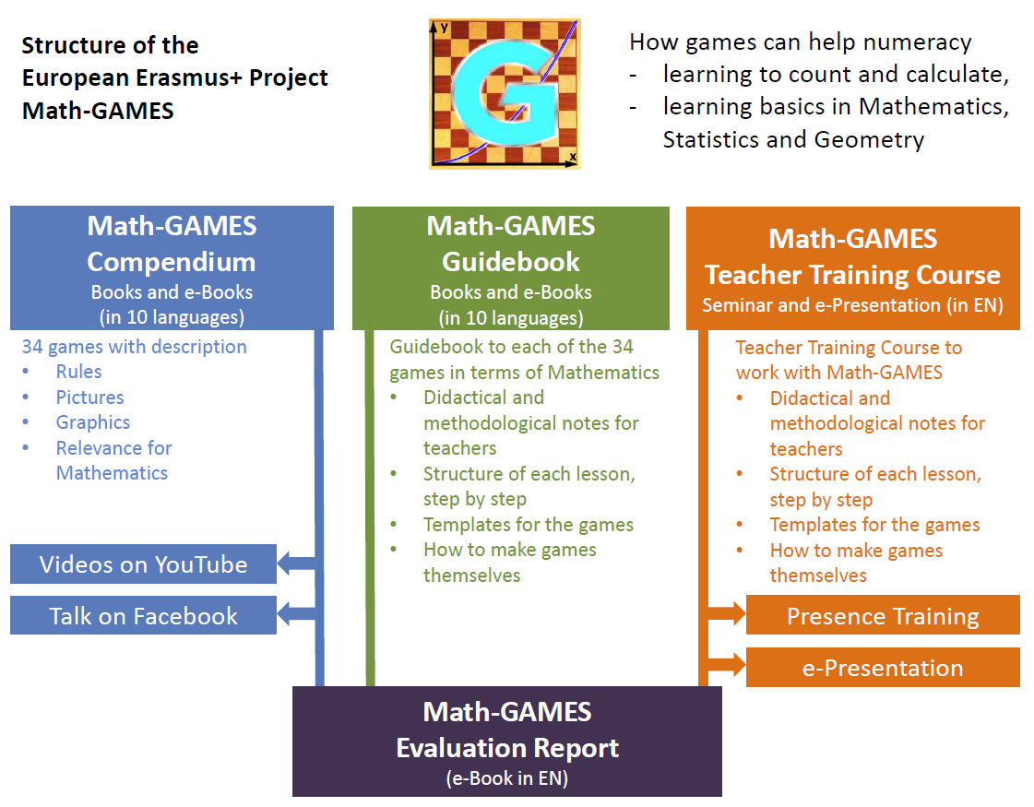The four parts of the output of the project Math-GAMES:

1. **Math-GAMES Compendium** of Famous Traditional Games, which are books in ten languages (BG, DE, EN, ES, FR, GR, IT, RO, VA, TR). After that the partners of the project will prove, how traditional games could be implemented in their learning program for a better understanding of mathematics, especially for lower skilled people, for young people and for immigrants, if there are needs.

The results are the **Math-GAMES Numeracy Learning Guidebooks** in nine languages.

In the third part of the project the project partners will prove by doing and testing during real courses and seminars that playing games between people with different skills assist in social integration and thus traditional games will be saved by transferring them to other people and they will not be lost. The result is a **Math-GAMES Teacher Training Course and Seminar**, which is held for the next years in different countries. The e-presentation, the seminar and the teacher-training course are published in English.

Finally the **Math-GAMES Testing and Evaluation Report** is published. It is a report about the project, the work, the activities during the lessons, the competitions in schools, the meetings and the evaluation. The Math-GAMES Project Report is published in English. All the Material is available from 2018 from the website [www.math-games.eu](http://www.math-games.eu)

*The authors of this compendium hope now that the users will have much joy in playing our games, because joy helps you to learn. In addition the authors hope to make a contribution that more people can apply basic mathematical content through this compendium.*

*Roland Schneidt*

*E-Mail:* [*roland.schneidt@web.de*](mailto:roland.schneidt@web.de)

# The Math-Games Methodology

## Mathematics and the Role of Games in Learning and Teaching - Why using Games in Learning Mathematics?

*by Andreas Skotinos, Cyprus*

**The Goals of Mathematics and its Centrality in an Adult’s Life**

It is generally agreed that doing mathematics is a critical skill for all, adults and children, geniuses and people with limited intelligence, persons with high education and individuals with low literacy and knowledge.

In quite a number of reports it is recognized and stressed that in order for adults to function (reasonably well) in an increasingly complex world, they require a basic level of numeracy, which is increasingly necessary in a range of life-skills, such as personal finance and data handling. It is also accepted that mathematical skills (at least at the very elementary level) are increasingly needed in the workplace and in everyday transactions between people.

It is not by chance that Aeschylus, 25 centuries ago, in the “Prometheus Bound” is adding that besides the fire, which Prometheus gave to people, he points out *“And yes, I invented for them numbers, too, the most important science”\**. This reveals the close relation of humans to mathematical literacy and their need to develop mathematical skills, at least at the elementary level.[1]

These basic skills are obviously reflected in the main goals of mathematics education, which are to prepare students to:

* Solve problems
* Communicate and reason
* Make connections between mathematics and its applications
* Become mathematically literate
* Appreciate and value mathematics
* Make informed decisions as contributors to society.

As can be seen the majority of these goals are immediately related to general life skills, that are expected for any adult and consequently it is justifiable to promote the learning of this subject to any person irrespective of his/ her ability and degree of intelligence.

**The Role of Games in Learning Mathematics**

So we have to promote Mathematics learning by any means. In view of this need the question now becomes “How can Games promote the Learning of Mathematics?” Particularly this question becomes more important in the case of Slow Adults Learners. The Background that can support a successful promotion of Games in the learning process can stem out of expectations that can have positive impact on the following aspects of human behavior: **cognitive, motivational, emotional and social**. Existing research, although not extensive as yet, supports this positive impact. Particularly in the case of Slow Adults Learners the positive impact on the motivational, emotional and social aspects is crucial and it is expected to have positive influence on the cognitive aspects as well.

In Psychology it is recognized that Play brings joy. And it is vital for problem solving, creativity and relationships. This is true for every person either a child or an adult. In particular this is vital for slow learners as it is one of the very few sources to provide these elements, while for other adults there may be other sources as well. Furthermore research in Psychology relates Play with much social behavior that we want either to enhance (if they are directing to the right direction) or to diminish (if they are leading to the wrong direction).

For instance, a psychologist found that lack of Play was just as important as other factors in predicting criminal behavior among murderers in Texas prisons.

Thus when we are dealing with the use of Games in the processes of teaching (and hence learning) we would better employ techniques and methods aiming at:

* **Creating Interest and Promoting Motivation**  
  A Game is a sequence of interesting choices. By engaging the learner in such a process motivation is activated and thinking (including critical one) is taking place.
* **Utilizing the Benefits That Games Provide in Engaging Learners in an Environment of Experiential and Active Learning**  
  The interaction in a game creates a better understanding for the learners in regards to the objects, concepts, processes and even the other learners involved
* **Socializing the Persons Involved and Exploiting the Competition and Challenge Element**  
  Games are part of everyday life-socialization. This is particularly important in the case of slow learners as their slowness might have its roots in their lack of social relations and interchanging eliminating ideas or low morale.
* **Connecting to Real Life Situations**  
  Quite many games reflect actual activities of life and thus they provide the element of usefulness.
* **Developing a Happy and Joyful Environment**  
  As already mentioned the joy element is a plus in the learning process.
* **Utilizing the Design (Structure, Rules, Equipment, Problem Posing etc.) of a Game in Order to Develop an Appropriate Learning Approach**  
  The components of a game, particularly the ones characterized by aesthetic, illustrative, energetic activities can be exploited for meaningful learning. Also the problem solving elements provide ample ideas for strategic and critical thinking.

**The Math-Games Methodology**

The Math-Games methodology encompasses a series of activities that will provide a teacher (and in particular a teacher of slow learners adults) the background for using Games as an educational medium in developing mathematical literacy. In this context it includes three main outcomes (a Math-Games Compendium, a Math-Games Guidebook and a Math-Games Teacher Training Course) that support various approaches and methods for learning and teaching.

**Factors that are to be considered in adopting the Math-Games methodology**

In designing a lesson through the adoption of the Math-Games methodology and considering that the main target group of learners is going to be slow adult learners it is useful to take into consideration a number of factors reflecting some of the possible difficulties of these learners. The effort will be to exploit the power of Games in order to alleviate or diminish these difficulties. Such factors include the following ones:

* **Language Issues**  
  In mathematics classes, language problems are evident when students have trouble using symbols of math, expressing math concepts to others, and listening to mathematics explanations. Problems also appear in expressing math “sentences”.
* **Cognitive Factors**  
  These may be attributed to perceptual, memory, attention or reasoning factors. Perception involves taking in information from the environment and processing that information for storage or use.
* **Metacognitive Factors**Metacognition is an awareness of the skills, strategies, and resources that are needed to perform a task and the ability to use self-regulatory mechanisms, including adjustments, to complete the task. Students with metacognition problems have trouble selecting and using effective learning strategies. Games could provide the forum to face such difficulties.
* **Motor Factors**  
  Motor skills, like perceptual ones, involve more than one process. They may involve memory of the symbol along with its actual formation (visual and motor memories). They may involve visual perception and transfer (copying). Or they may involve integration of fine muscles with task demands. Indicators of motor problems are highly visible: poorly formed symbols, little control of spacing, excessive time for a task, and avoidance of written work.
* **Social and Emotional Factors**  
  Such factors cover a very broad spectrum including peer relations, cooperation, self-esteem etc. Games again could provide a medium for facing them.
* **Habits of Learning**  
  “Habits of learning” refers to how individuals view and participate in learning, their self-discipline and self-motivation, goal setting, engagement in learning activities, and acceptance of challenges.
* **Previous Experiences**  
  Particularly in the case the learner had negative previous experience he refuses to get involved in the learning process. Games again could alleviate such negative experiences.

Consequently what we have to take into consideration in designing our plan for teaching using the Math-Games methodology could be summarized as:

* Type of slow learner (is the slowness due to other learning areas?)
* Background in Math
* Socialization needs of the person
* Motivation needs and indications that the mathematical content of the game relates to everyday life
* Provision of opportunities for the use of the previously mentioned benefits

**General Approaches for Using Games in Learning Mathematics**

Obviously the approach one will adopt for using Games in the learning process depends on a number of goals that we want to achieve ranging from the mathematical area or topic to the considerations mentioned just in the previous paragraphs, reflecting the benefits of the methodology. In this context we can suggest the following approaches:

* **Using the Methodology as an Introduction to a Mathematical Topic**  
  The idea is to ask the learners to play a game that can be associated with the learning objectives of the particular game. Playing a game can be used as a brainstorming. This idea is expected to be the basis for motivation and developing of interest. It can also be used as an icebreaker both for the relations of the people involved in the learning process (learners and teacher) and for the attitudes of the learners towards mathematics (which are usually negative).
* **Using the Methodology for Creating a Happy and Joyful Environment**  
  This idea develops positive conditions for learning and thus overcoming negative attitudes and anxiety.
* **Using the Methodology as an Actual Educational Medium for Comprehension of Mathematical Concepts and Processes**  
  Obviously such an approach is a substitute for a more traditional one with the advantage that it exploits the benefits of the methodology.
* **Using the Methodology for Consolidation of Otherwise Learned Concepts or Processes**  
  It is a fact that learning process, particularly for mathematics, demands such an approach.
* **Using the Methodology for Relating Mathematics to Real Life Situations**  
  The identification of uses of mathematics for real life situation is an asset for adults as the need to see applications of what they have to learn.
* **Using the Methodology for Developing Problem Solving and Critical Thinking Skills**  
  It is a major goal that every learner develops such skills. Games are ideal for strategic thinking, planning and designing approaches to face problematic issues. It provides the forum for meaningful learning and not just rote memorization.
* **Using the Methodology for Boosting Creativity, Productivity and Innovation**  
  This idea enhances the skills of the learners and provides a fruitful approach for learning. It can be utilized for adaptation of games or constructing new ones by the players.
* **Using the Methodology for Fixing Relationship Difficulties among the Learners**  
  As mentioned earlier such an approach can create a cooperative, challenging and joyful environment, thus creating ideal conditions for learning.

The following table indicates some examples for the various approaches that are presented in this Guidebook:

|  |  |
| --- | --- |
| **Approach** | **Game presented in the  Math-Games Compendium and in the Guidebook** |
| Introduction to a Topic | 1.2 Checkers |
| Joyful Environment | 4.1 Petanque |
| Educational medium | 1.3. Damath, 10.1 Okey, 3.2 Math Scrabble |
| Consolidation | 10.3 Sudoku |
| Math in Real Life | 3.3 Monopoly |
| Problem Solving and Critical Thinking | 2.3 Combination 9, 7.1 Magic Square, 9.3 Nim-Game |
| Creativity, Productivity, Innovation | 1.4 Tangram, 8.2 Skipping Rope |
| Fixing Relationships | 5.2 Seven Steps, 8.3 Hora |

## Hints to use this Guidebook

* **The objective of the guidebook is to provide teachers and educators with material to help them teach basic skills in mathematics.**
* **The guidebook includes 33 games.**
* **The best way for the teachers to choose the one that better suits them is to check the Synopsis (p. 10) where there is a list of the games and also the mathematical content that is associated with each one.**
* **Each section of the guidebook is dedicated to one game.**

# Structure of this Book - How to use this Guidebook?

## **Each chapter of this Guidebook consists usually of**

## Preliminary Remarks on the Lesson

with objectives, hints for tools, materials and organisation, with description of the lesson and with other useful remarks, to read by the teacher when preparing the lesson

## 

## 

## 

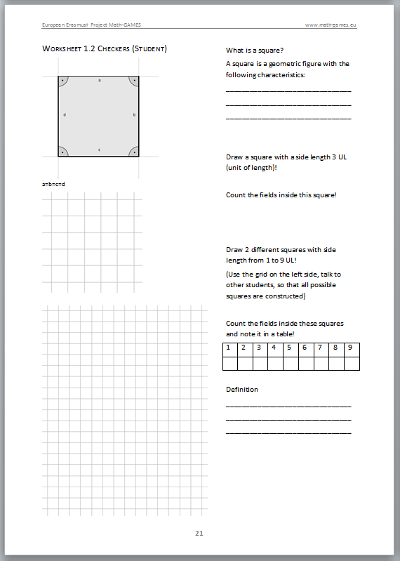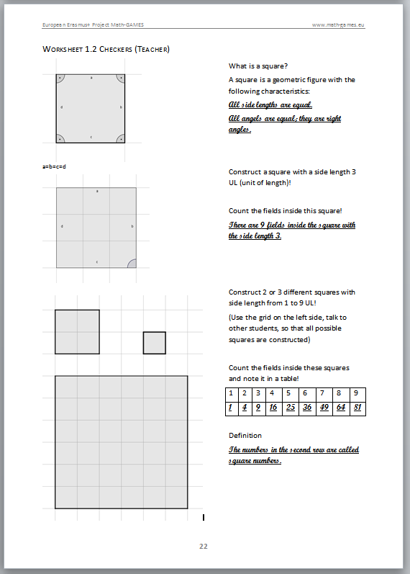

## Worksheet for the Learners

with gaps and free areas to be completed by the student during the lesson

## Worksheet for the Teachers with already filled in gaps and free

as a basis for the teacher during the lesson

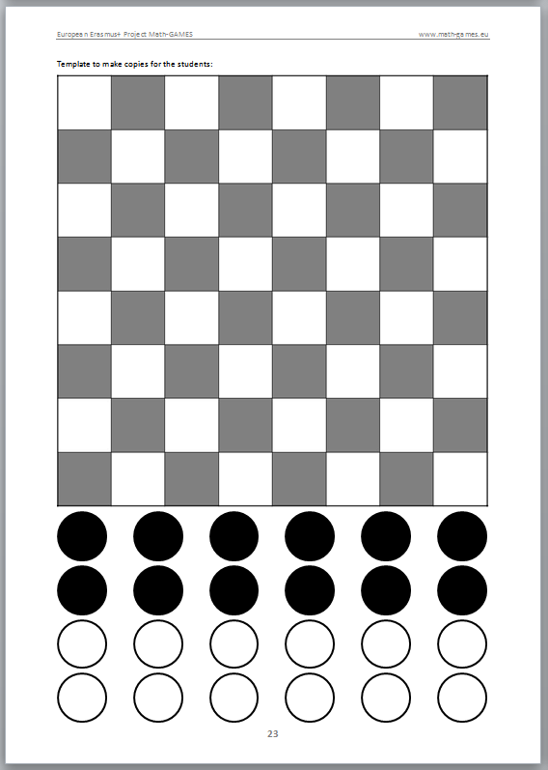

Copying templates and other material

with which the teacher can prepare his lesson more easily

# 3.2 Math Scrabble (Board Game)

## Objectives

This game can be used to attain a broad range of objectives depending on the background of the learners the degree and the causes of their characterization as slow learners and all the related issues. Among these we identify the following ones as particularly attainable through this.

**Objectives for Mathematical Content**

C1. Recognize the meaning/ representation of the digits **0 1 2 3 4 5 6 7 8 9** and the symbols **+ - × ÷ = ( )**

C2. Recognize the meaning and representation of positive integers in the range 0 … 1000.

C3. Adding, subtracting, multiplying and dividing integers in the range 0 … 100.

C4. Using a calculator for the above operations

C5. Constructing/ Writing equalities, using the symbols that are part of the MathScrabble game

C6. Checking the validity of an equality

C7. Understand a coordinate system and identify positions on it

**Objectives for the Development of General Mathematical Skills and Competencies**

M1. Develop positive attitudes towards mathematics

M2. Build knowledge by taking advantage on interest and background experience of the learners

M3. Provide opportunities for exploring mathematical entities concepts and processes

M4. Encourage estimation skills

M5. View computation as a tool for problem solving and not as an end in itself

M6. Encourage multiple solutions strategies

M7. Develop students’ calculator skills

M8. Provide opportunities for cooperation and group work

M8. Link numeracy and literacy skills

M9. Situate problem solving tasks in the context of real issues

M10. Develop skills for interpreting linguistic information and transferring it to numerical representation

M11. Develop problem solving skills (understanding a problem, devising a plan, implementing a plan, assessing the solution)

M12. Develop reasoning skills

## Tools, Materials and Organisation

In order to develop lessons through the exploitation of the Math Scrabble game it is expected that to use the Equipment for the game plus supporting material that provides supplementary illustrations that will help the students in developing their mathematical skills. This game material it is going to be needed:

## The Board for the game

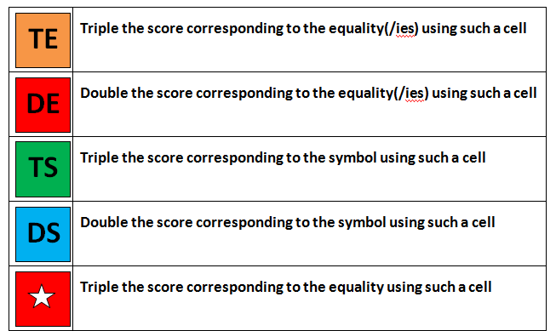In addition and in order to facilitate the running of the game the following sheets are given aiming at helping the learners to keep track of the various activities: A card explaining the notation of the symbols on used on the board and a board with a system of coordinates.

You need tiles (see next page):

5×10 Tiles with numbers from 0 to 9

7×2 Tiles for Symbols + and –

5×22 Tiles for Symbols × and ÷

7×2 Tiles for Symbols ( and )

20 Tiles with the Symbol =

4 Tiles are empty (Joker)

## Kopiervorlage

**0**

**Scoring 1**

**1**

**Scoring 1**

**2**

**Scoring 1**

**3**

**Scoring 2**

**4**

**Scoring 2**

**5**

**Scoring 3**

**6**

**Scoring 2**

**7**

**Scoring 4**

**8**

**Scoring 2**

**9**

**Scoring 2**

**0**

**Scoring 1**

**1**

**Scoring 1**

**2**

**Scoring 1**

**3**

**Scoring 2**

**4**

**Scoring 2**

**5**

**Scoring 3**

**6**

**Scoring 2**

**7**

**Scoring 4**

**8**

**Scoring 2**

**9**

**Scoring 2**

**0**

**Scoring 1**

**1**

**Scoring 1**

**2**

**Scoring 1**

**3**

**Scoring 2**

**4**

**Scoring 2**

**5**

**Scoring 3**

**6**

**Scoring 2**

**7**

**Scoring 4**

**8**

**Scoring 2**

**9**

**Scoring 2**

**0**

**Scoring 1**

**1**

**Scoring 1**

**2**

**Scoring 1**

**3**

**Scoring 2**

**4**

**Scoring 2**

**5**

**Scoring 3**

**6**

**Scoring 2**

**7**

**Scoring 4**

**8**

**Scoring 2**

**9**

**Scoring 2**

**0**

**Scoring 1**

**1**

**Scoring 1**

**2**

**Scoring 1**

**3**

**Scoring 2**

**4**

**Scoring 2**

**5**

**Scoring 3**

**6**

**Scoring 2**

**7**

**Scoring 4**

**8**

**Scoring 2**

**9**

**Scoring 2**

**=**

**Scoring 2**

**=**

**Scoring 2**

**=**

**Scoring 2**

**=**

**Scoring 2**

**=**

**Scoring 2**

**=**

**Scoring 2**

**=**

**Scoring 2**

**=**

**Scoring 2**

**=**

**Scoring 2**

**=**

**Scoring 2**

**=**

**Scoring 2**

**=**

**Scoring 2**

**=**

**Scoring 2**

**=**

**Scoring 2**

**=**

**Scoring 2**

**=**

**Scoring 2**

**=**

**Scoring 2**

**=**

**Scoring 2**

**=**

**Scoring 2**

**=**

**Scoring 2**

**+**

**Scoring 1**

**­­–**

**Scoring 1**

**+**

**Scoring 1**

**­­–**

**Scoring 1**

**+**

**Scoring 1**

**­­–**

**Scoring 1**

**+**

**Scoring 1**

**­­–**

**Scoring 1**

**+**

**Scoring 1**

**­­–**

**Scoring 1**

**+**

**Scoring 1**

**­­–**

**Scoring 1**

**+**

**Scoring 1**

**­­–**

**Scoring 1**

**×**

**Scoring 2**

**­­÷**

**Scoring 3**

**×**

**Scoring 2**

**­­÷**

**Scoring 3**

**×**

**Scoring 2**

**­­÷**

**Scoring 3**

**×**

**Scoring 2**

**­­÷**

**Scoring 3**

**×**

**Scoring 2**

**­­÷**

**Scoring 3**

Leerer Spielstein kann überall als Joker eingesetzt werden.

**Scoring 0**

**­­**

**Scoring 0**

**Scoring 0**

**­­**

**Scoring 0**

**(**

**Scoring 5**

**)**

**Scoring 5**

**(**

**Scoring 5**

**)**

**Scoring 5**

**(**

**Scoring 5**

**)**

**Scoring 5**

**(**

**Scoring 5**

**)**

**Scoring 5**

**(**

**Scoring 5**

**)**

**Scoring 5**

**(**

**Scoring 5**

**)**

**Scoring 5**

**(**

**Scoring 5**

**)**

**Scoring 5**

**Sheets for Scoring in a Single round**

**Information-Card 2: MATHSCRABBLE RULES -RULES FOR SCORING**

**For the scoring in each round**

1. Find the total of the score by considering the point value of the tiles used for the construction of the present equality plus the extra points that can be gained from the consideration of the indications on the board in the squares that are used. The latter advantage (getting extra points as it is indicated on the squares of the board) counts only for the first time that a tile is placed on the board.
2. In case all nine tiles are used in the present round an extra bonus of 40 points is added for the score in the round.

**For the scoring at the end of the game**

Further to the total score of each player we have the following two cases depending on how the game ends:

1. In case (a) the score of the player that goes out is increased by adding the score values of the tiles with which the other players are left.
2. In case (b) the score of each player is decreased by the sum of the score values of the tiles with which he is left.

**Information-Card 1: MATHSCRABBLE RULES - RULES FOR PLAYING**

1. Each player takes initially 9 tiles from the bag.
2. Then each player is expected to construct, if possible, a valid equality using all or some of the tiles in his hand.
3. The first player that has a valid equality has to place it on the board by placing the symbol “=” in the central square (denoted by the star) and by arranging the other tiles either horizontally or vertically.
4. Equality can be read horizontally or vertically.
5. In each turn a **new (additional) symbol “=”** can be used only once, that is if a player has in his/ hers hand two or more symbols “=” he/ she is allowed to use at most one of them for his/hers turn.
6. A player can construct a valid equality by constructing a new equality or by extending an existing one by using already positioned tiles on the board for developing one or more new ones , that is expressions with more than two equal parts (e.g. 1+1=2=5-3=8÷4)
7. Each player keeps always 9 tiles in his hand, thus after he/ she has constructed an equality he/ she picks up from the bag the same number of tiles as the ones he/ she has used for the construction. This requirement does not apply if there are no more tiles in the bag and in this case the player is left with less than 9 tiles.
8. The symbol “-“ can be used either as the sign of a negative number or as the symbol of subtraction.
9. The game ends when either
10. There are no other tiles in the bag and the last player used all his tiles, or
11. There are no other tiles in the bag and no player can go out (i.e. can construct any valid equality and use all his tiles)

|  |  |
| --- | --- |
| **Equality** |  |
| Score due to scoring value on the tiles used to construct the equality |  |
| Score adjusted due to benefits of symbols, as specified by using squares marked DS the Board |  |
| Score adjusted due to benefits of equalities as specified by using squares marked DE on the Board |  |
| Score adjusted due to bonuses or penalties |  |
| **Total score for the round** |  |

**Sheets for keeping the records of scores for each player during the game**

|  |  |  |  |  |
| --- | --- | --- | --- | --- |
| **Round** | **Player 1** | **Player 2** | **Player 3** | **Player 4** |
| Round 1 |  |  |  |  |
| Round 2 |  |  |  |  |
| ….. |  |  |  |  |
| **Total Score** |  |  |  |  |

## Math-Scrabble Lesson 3.2.1: Getting acquainted with basic mathematical concepts used in MathScrabble

A lesson of 40 to 45 minutes duration

This lesson can be used as an Introduction to the ideas that concern the basic arithmetic symbols and other mathematical ideas as well as what they represent. Furthermore it provides the opportunity for developing skills for creativity and innovation.

In particular this lesson aims at objectives C1, C2, C7, M1, M2, M3 and M11

Through this approach it is aimed to enable the students to recognize these symbols and to express what they stand for. In order to achieve this it is suggested to show them the basic tools of the MathScrabble game and ask them to construct them and explain what these represent or how they can be used in a mathematical context. Knowing the importance of their children to the majority of adults it is suggested that we can ask them to construct the various

Tools that are needed in playing the game, by stressing that this game can be of help to their children for learning mathematics. This can prove to be an additional motivating factor.

In this lesson it is proposed

1. to present to the students the tools and other material that are used in the MathScrabble
2. to explain the meaning of these tools
3. to present the rules of the game
4. to help the learner in constructing and innovating

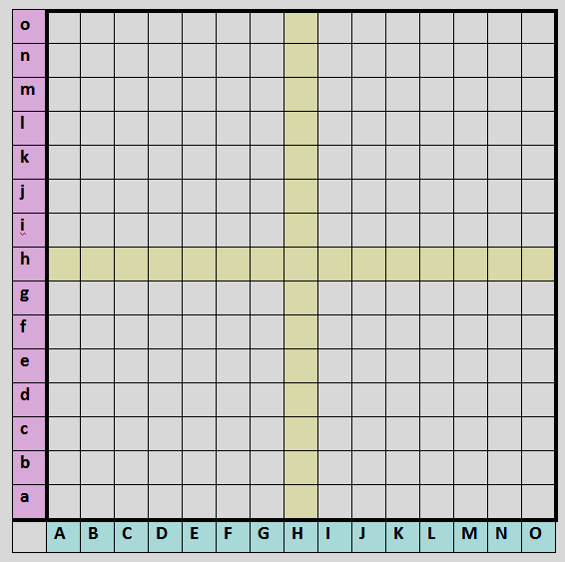

## Worksheet 3.2.1 (Learner)

|  |  |
| --- | --- |
| **Information** | **Requirements/ Questions for practice/ Comments** |
| Given the following tiles | Name in your language and Explain the meaning of each of them.  What is the value for the scoring on each of them?  Which of them are arithmetical digits?  Which of them are symbols for an arithmetic operation?  Which symbol represents the equality of various quantities?  What is the role of the “blank” symbol? |
| Consider the Board in its marked form that helps to identify the positions of the cells: | Mark, using a red pencil, the positions of the following cells:  (A,a), ( B,c), (H,h), ( M,c), (D,g)  What do we mean by the coordinates of a cell?  Find the coordinates of the following cells:  The cell in the column marked by K and the row marked by e  The cell in the row marked by a and the column marked by G  The cell that is determined by the arrows:  Arrow 1: ( )  Arrow 2: ( ) |
| Consider the Board in its actual form: | What happens if a tile is placed in the following cells (provided that it is valid to place it there):  in (A, a) -> ______  in (D, d) -> ______  in (F, b) -> ______  in (H, h) -> ______  in (L, o) -> ______ |
| Given the cards with the rules for playing the game | Read the rules and reflect on these rules.  Which terms/ concepts do you feel that you know and which you consider as not clear  Discuss these ideas between you |
| Given cardboard, a pair of scissors, colored pencils,  Geometrical instruments | Construct the various tools we need for playing MathScrabble  What other material could you think of using for the construction of the Board, the tiles and whatever else we need?  Can you think of more sophisticated constructions? Can you cooperate in achieving such aims?  Discuss these ideas between you |

## Worksheet 3.2.1 (Teacher)

|  |  |
| --- | --- |
| **Questions/ issues for discussion/ reflection** | **Comments/ remarks** |
| What are the tools we need for playing MathScrabble?  Can you explain how do you plan to introduce these tools to the learners? | Obviously the teacher should be aware of the tools and other supporting material for the game |
| How do you identify probable weaknesses of the learners concerning the meaning / representation of the symbols used on the tiles and the form of the Board?  Can you take up the opportunity for helping them to consolidate these representations? | As the range of reasons for the weaknesses is quite broad it is important to develop some tools for identifying them and adapt the approach. For example if the learners are immigrants with very vague knowledge of the language the teacher should use appropriate approaches for explanations. |
| How do we explain the coordinating system that can be used for accessing the various cells on the Board?  Can you develop examples/ exercises for it? |  |
| How do you help the learners to comprehend the rules for the game? | One of the main problems we face in the learning process is the overcoming of the difficulties for reading and understanding. |
| How do you help the learners in constructing the basic tools and other supporting material?  Can you develop a set of instructions for this? | By challenging the learners to construct we achieve a fruitful, pleasant and effective learning |
| Can you think of other issues for discussion/ reflection in order to achieve the objectives C1, C2 M1, M2, M3? |  |
| Can you develop worksheets for the learners (in the spirit of the ones that follow)? | These might be similar or extensions of the ones that follow, but also might be altogether different aiming at either extending the ideas achieving the aims of the lesson or attending particular difficulties of the learners, depending on the reasons for their slowness. |

## Math-Scrabble Lesson 3.2.2: Constructing Equalities using the MathScrabble Symbols

A lesson of 40 to 45 minutes duration

This lesson can be used as an opportunity for consolidation of the basic arithmetic operations and the idea of equality as a relation connecting equal quantities. Furthermore it provides the opportunity for developing problem solving and critical thinking skills. In particular this lesson aims at objectives C1, C2, C3, C4, C5, C6, M1, M2, M3, M6, M7, M8, M11, M12, M13.

Through this approach it is aimed to enable the students to recognize the meaning of equality and to provide them with opportunities for identifying valid ones. Furthermore it is expected to provide opportunities for constructing ones themselves using as many tiles as possible.

In this lesson it is proposed

1. to present to the students the idea of an equality
2. to provide opportunities for basic arithmetic operations
3. to understand the process of simple problem solving

In solving the simple problem of constructing equalities, it is useful, to follow the next process:

* Do we understand the problem? (What are the data, what is required; do we know what are the meaning /role of the various terms involved?)
* Can we devise a plan of how to work? (can we construct quantities (in the form of a mathematical expression) on two sides using the tiles and calculate the outcome for each side)
* Can we implement our plan? (by putting down the various expressions and doing the calculations for each side) and give an answer
* Can we investigate the correctness of our answer? (Is our answer valid? Is this the only answer? Is this the best answer?)

## Worksheet 3.2.2 (Teacher)

|  |  |
| --- | --- |
| **Questions/ issues for discussion/ reflection** | **Comments/ remarks** |
| How do we consider the issue of quantity?  How do we explain the concept of equality? | Does the traditional weighing scale provide a helpful approach? |
| Provide sets of tiles aiming at using them for constructing quantities (using basic arithmetic operations) and calculating the outcome |  |
| Provide groups of equalities and ask to identify the valid ones | It is an opportunity for discussion of what is involved in checking the validity of an equation |
| Provide sets of tiles and ask the learner to construct equalities | It is an opportunity for discussion of the process of problem solving |
| Develop worksheets for the learners aiming at calculating quantities and constructing valid equalities, using the tools of the MathScrabble. | The examples that follow are indicative but obviously you can develop many other worksheets |
| Solution of the last question page 64 | 2*5-1=6/3+7 |

## Worksheet 3.2.2 (Learner)

|  |  |
| --- | --- |
| **Information** | **Requirements/ Questions for practice/ Comments** |
| Given are the following expressions (equations):   1. 5+3 = 8 2. 8-2 = 2×3 3. 4÷2 = 2+0 4. 12 = 6+2 5. 7 - 2×2 = 10 - 7 6. 9 - 6÷3 = 5+2 | Which expression/quantity is the left side and which one is the right side?  What is the outcome of the each expression (left or right side) for each relation?  **These equations are all valid expressions! In the game you always use valid expressions!** |
| Given the following tiles  , , , , , , , , | Find the outcome for each of the following expressions using tiles from the given set to present your answer |
| Given the following nine tiles  , , ,  , , , , , | Which of the following relations can be constructed using these tiles and which of them are valid ones? $5+1=6$ $6-2=5-1$ $6÷2=3$ $3+1=6-2$ $3 ×2=6$ $5-2=3$ $6-5=3-2$ $5-1=6+2-3$ |
| Given the following nine tiles  , , , , , , , , | Construct valid equalities using **some** of these tiles!  Find three different equations!  Calculate the score value of these equations! |
| Given the following nine tiles    , , | Construct valid equalities using **all** of these tiles!  (Solution see teacher’s part)  Calculate the score value of the equation! |

## Math-Scrabble Lesson 3.2.3: Constructing Equalities and Placing them on the Board Using the Symbols

A lesson of 40 to 45 minutes duration

This lesson can be used as an opportunity for consolidation of the basic arithmetic operations and the idea of equality as a relation connecting equal quantities. Furthermore it provides the opportunity for developing problem solving and critical thinking skills. In particular this lesson aims at objectives C1, C2, C3, C4, C5, C6, M1, M2, M3, M6, M7, M8, M11, M12, M13. The additional effort for this lesson is that the learner will have to utilize/ exploit already existing equalities on the Board by adding his/ hers tiles and create new ones.

Through this approach it is aimed to enable the students to recognize the meaning of equality and to provide them with opportunities for identifying valid ones. Furthermore it is expected to provide opportunities for constructing ones themselves using as many tiles as possible.

In this lesson it is proposed

1. to provide opportunities for basic arithmetic operations and for using the symbols included in the tools of the game
2. to place tiles on the Board so that they represent valid equalities and so that they are making use of already existing ones
3. to oblige them to check the work of their competitors and to exploit the various developments in order to achieve the best for themselves
4. to understand the process of simple problem solving

## Worksheet 3.2.3 (Teacher)

|  |  |
| --- | --- |
| **Questions/ issues for discussion/ reflection** | **Comments/ remarks** |
| What are some important points that have to be taken into consideration when a learner has to place his/ hers equality on the Board? | Consider tiles on the Board and what are in player’s hands  Construct various equalities using all the tiles  Work vertically and horizontally  Have in mind the score (see next lesson)  Distinguish the approach of the first round from the others  The need to play so that the player managing the best for themselves and also hindering the next players. |
| How do we communicate with the learners in order to understand the positions (coordinates) for placing their tiles  How do we challenge them in order to achieve solutions with the various advantages? |  |
| Construct worksheets for the learners so that they are given tiles in succession and they are asked to place them on the Board according to the rules of the game | The example in sheet 8 is indicative of the process |

## Worksheet 3.2.3 page 1 (Learner)

|  |  |
| --- | --- |
| **Information** | **Requirements/ Questions for practice/ Comments** |
| The following tiles are in the hands of Player 1  1, 2, 3, 4, 6, +, – , =, ÷ | Construct an equality and place it on the Board |
| An answer given to the previous question is the following | Check whether this is a valid equality and whether it abides by the rules of the game.  Explain your position  At what coordinates is the symbol “=” placed? |
| The following tiles are in the hands of Player 2 when asked to go for the second round of the game  0, 1, 3, 4, 5,9, +, – , =, ÷ | Construct an equality and place it on the Board |
| An answer given to the previous question is the following | Check whether this is a valid equality and whether it abides by the rules of the game.  Explain your position  At what coordinates is the symbol “=” placed?  How many of the tiles in his hand does he use? |

## Worksheet 3.2.3 page 2 (Learner)

|  |  |
| --- | --- |
| The following tiles are in the hands of Player 3 when asked to go for the third round of the game  0, 1, 3, 4, 5,7, +, – , =, × | Construct an equality and place it on the Board |
| An answer given to the previous question is the following | Check whether this is a valid equality and whether it abides by the rules of the game.  Explain your position  At what coordinates is the symbol “=” placed?  How many of the tiles in his hand does he use? |
| The following tiles are in the hands of Player 4 when asked to go for the fourth round of the game  0, 1, 2, 3, 7, +, – , =, =, × | Construct an equality and place it on the Board |
| An answer given to the previous question is the following | Check whether this is a valid equality and whether it abides by the rules of the game.  Explain your position  At what coordinates is the symbol “=” placed?  How many of the tiles in his hand does he use? |

## Lesson 3.2.4: Constructing Equalities, Placing them on the Board and Calculating the Score Corresponding to them, According to the MathScrabble Rules

A lesson of 40 to 45 minutes duration

This lesson can be used as an opportunity for consolidation of the basic arithmetic operations and the idea of equality as a relation connecting equal quantities. Furthermore it provides the opportunity for developing problem solving and critical thinking skills. In particular this lesson aims at objectives C1, C2, C3, C4, C5, C6, M1, M2, M3, M6, M7, M8, M11, M12 and M13. The additional effort for this lesson is that the learner will have to utilize/ exploit already existing equalities on the Board by adding his/ hers tiles and create new ones.

Further to the aim to enable the students to recognize the meaning of an equality and constructing ones themselves using as many tiles as possible, in this lesson the learner will have to calculate the score corresponding to these equalities according to the game’s rules. Thus the learner is practicing calculation skills and problem solving skills.

In this lesson it is proposed

1. to provide opportunities for basic arithmetic operations and for using the symbols included in the tools of the game
2. to place tiles on the Board so that they represent valid equalities and so that they are making use of already existing ones
3. to oblige them to check the work of their competitors and to exploit the various developments in order to achieve the best for themselves
4. to provide opportunities for calculating the score for each round of the game, taking into consideration the values of the tiles and the extra scoring due to the placing of the equality on the Board or/and the bonuses for certain achievements
5. to understand the process of simple problem solving

## Worksheet 3.2.4 (Teacher)

|  |  |
| --- | --- |
| **Questions/ issues for discussion/ reflection** | **Comments/ remarks** |
| What are some important points that have to be taken into consideration when a learner has placed his/ hers equality on the Board and has to consider how to calculate the corresponding score for the particular round? | Consider the constructed equality for the particular round and where it has been placed on the Board.  Use the sheet for calculating the score for each round |
| How do we explain to the learners the various points they need in order to understand the process of scoring. |  |
| Construct worksheets for the learners so that they are given equalities in succession placed on the Board and ask them to calculate the corresponding score according the rules of the game | The example in sheet 11 is indicative of the process |
| Construct worksheets for the learners so that they are given instructions for actually playing the game |  |

## Worksheet 3.2.4 Page 1 (Learner)

|  |
| --- |
| Given the actual Board and the equality for Player 1 |
| Using the rules for scoring complete the following scoring sheet for Round 1   |  |  | | --- | --- | | **Equality** |  | | Score due to scoring value on the tiles used to construct the equality |  | | Score adjusted due to benefits of symbols, as specified by using squares marked DS the Board |  | | Score adjusted due to benefits of equalities as specified by using squares marked DE on the Board |  | | Score adjusted due to bonuses or penalties |  | | Total score for the round |  | |
| Given the actual Board and the equality presented in Worksheet 3.2.3a for Player 2 |

## Worksheet 3.2.4 Page 2 (Learner)

|  |  |  |  |  |  |  |  |  |  |  |  |  |
| --- | --- | --- | --- | --- | --- | --- | --- | --- | --- | --- | --- | --- |
| Using the rules for scoring complete the following scoring sheet for Round 2   |  |  | | --- | --- | | **Equality** |  | | Score due to scoring value on the tiles used to construct the equality |  | | Score adjusted due to benefits of symbols, as specified by using squares marked DS the Board |  | | Score adjusted due to benefits of equalities as specified by using squares marked DE on the Board |  | | Score adjusted due to bonuses or penalties |  | | Total score for the round |  | |
| Given the actual Board and the equality presented in Worksheet 3.2.3a for Player 3 |
| Using the rules for scoring complete the following scoring sheet for Round 3   |  |  | | --- | --- | | **Equality** |  | | Score due to scoring value on the tiles used to construct the equality |  | | Score adjusted due to benefits of symbols, as specified by using squares marked DS the Board |  | | Score adjusted due to benefits of equalities as specified by using squares marked DE on the Board |  | | Score adjusted due to bonuses or penalties |  | | Total score for the round |  | |

## Worksheet 3.2.4 Page 3 (Learner)

|  |
| --- |
| Given the actual Board and the equality presented in Worksheet 3.2.3a for Player 4 |
| Using the rules for scoring complete the following scoring sheet for Round 4   |  |  | | --- | --- | | **Equality** |  | | Score due to scoring value on the tiles used to construct the equality |  | | Score adjusted due to benefits of symbols, as specified by using squares marked DS the Board |  | | Score adjusted due to benefits of equalities as specified by using squares marked DE on the Board |  | | Score adjusted due to bonuses or penalties |  | | Total score for the round |  | |

# 3.3 Monopoly (Board Game)

## Objectives

This game can be used to attain a broad range of objectives depending on the background of the learners the degree and the causes of their characterization as slow learners and all the related issues. It is a game that is immediately connected with the everyday applications of mathematics and particularly the ones that relate with money. As its name (Monopoly) stresses it is a game that deals with selling and buying, an activity that makes the learning of mathematics a necessity for everybody. The game concerns the dealings with property and it can be a strong motive for an adult to understand the process and the main goal which is to give the opportunity to the players to become wealthier (actually the winner of the game is the one that manages to have the assets with the highest value). The game is even useful for the people with a socialist philosophy, as by learning it they can understand the economic processes in the market and promote some actions for alleviating them (If you want to fight something you have to know it and understand it).

Among the objectives that can be promoted with this game we identify the following ones as particularly attainable through this.

**Objectives for Mathematical Content**

C1. Recognize the meaning/ representation of the digits **0, 1, …, 9** and the symbols **+ - × ÷ = ( )**

C2. Recognize the meaning and representation of positive integers in the range 0, …, 1000000

C3. Adding, subtracting, and multiplying integers in the range 0, …, 1000000

C4. Using a calculator for the above operations

C5. Understanding the fact that there is a relation of order in the set of integers and recognize how to compare such numbers

C6. Use the symbols <, >, and checking the order of integers

**Objectives for the Development of General Mathematical Skills and Competencies**

M1. Develop positive attitudes towards mathematics

M2. Build knowledge by taking advantage on interest and background experience of the learners

M3. Provide opportunities for exploring mathematical entities concepts and processes

M4. Encourage estimation skills

M5. Develop communication skills, using mathematical entities

M6. View computation as a tool for problem solving and not as an end in itself

M7. Encourage multiple solutions strategies

M8. Develop students’ calculator skills

M9. Provide opportunities for cooperation and group work

M10. Link numeracy and literacy skills

M11. Situate problem solving tasks in the context of real issues

M12. Develop skills for interpreting linguistic information and transferring it to numerical representation

M13. Develop problem solving skills (understanding a problem, devising a plan, implementing a plan, assessing the solution)

M14. Develop reasoning skills

## Tools, Materials and Organisation

In order to develop lessons through the exploitation of the Monopoly game it is expected to use the Equipment for the game plus supporting material that provides supplementary illustrations that will help the students in developing their mathematical skills. This material is presented in the ADENDUM for the Section 3.3 MONOPOLY of the Guidebook. It is expected that the users of the game should have to buy a set, or more if needed, for playing the game, from a commercial shop. The game is available in the majority of the bookstores or big stationary shops, or even supermarkets for a reasonable price. The game has been translated in the majority of the European Languages as well as in many other languages.

Alternatively the material needed can be constructed by the learners with the additional value of giving them the opportunity for creation and comprehension of the various ideas involved

## Lesson 3.3.1: Getting acquainted with basic mathematical concepts used in MONOPOLY

A lesson of 40 to 45 minutes duration

This lesson can be used as an **Introduction** to the ideas that concern the basic arithmetic symbols and other mathematical ideas as well as what they represent. Particularly it can provide the opportunity for comparing two or more quantities and use them in every day transaction, thus providing the need for learning mathematics and realizing that it is an entity with broad **applications** in everyday life. Furthermore it provides the opportunity for developing skills for **creativity and innovation**.

In particular this lesson aims at objectives C1, C2, C5, C6, M1, M2, M3, M5, M11

Through this approach it is aimed to enable the students to recognize what numbers stand for and connect them immediately with values – money.

In this lesson it is proposed

* to present to the students the tools and other material that are used in Monopoly and identify the connection with real life
* to demonstrate the need for understanding mathematical concepts as a basic instrument in everyday life transactions
* to help the learner in constructing and innovating.

## Worksheet 3.3.1 (Teacher)

|  |  |
| --- | --- |
| **Questions/ issues for discussion/ reflection** | **Comments/ remarks** |
| What are the tools we need for playing Monopoly?  Can you explain how do you plan to introduce these tools to the learners? | Obviously the teacher should be aware of the tools and other supporting material for the game. Use the ADDENDUM Tools for Monopoly Present to the students the various materials for the game as can be acquired/ supplied from a commercial shop |
| How do you identify probable weaknesses of the learners concerning the meaning of the mathematical concepts that can be found on the Board as well as on the various cards Can you take up the opportunity for helping them to consolidate these representations? | As the range of reasons for the weaknesses is quite broad it is important to develop some tools for identifying them and adapt the approach. For example if the learners are immigrants with very vague knowledge of the language the teacher should use appropriate approaches for explanations |
| How do you help the learners to comprehend the rules for the game? | One of the main problems we face in the learning process is the overcoming of the difficulties for reading and understanding. |
| How do you help the learners in constructing the basic tools and other supporting material?  Can you develop a set of instructions for this? | By challenging the learners to construct we achieve a fruitful, pleasant and effective learning |
| Can you think of other issues for discussion/ reflection in order to achieve the objectives  C1, C2, C5, C6, M1, M2, M3, M5, M11 |  |
| Can you develop worksheets for the learners (in the spirit of the ones that follow)? | These might be similar or extensions of the ones that follow, but also might be altogether different aiming at either extending the ideas achieving the aims of the lesson or attending particular difficulties of the learners, depending on the reasons for their slowness. |

## Worksheet 3.3.1 Page 1 (Learner)

|  |  |
| --- | --- |
| **Information** | **Requirements/ Questions for practice/ Comments** |
| Given the Board for the game (Provided that this is very small representation use the Board of the game that you have in your class or at home) | Go over the various cells and identify on each of them the various stated numbers.  Explain what these numbers represent.  At what cells do you expect to have the opportunity of receiving money, how much and under what conditions?  At what cells do you expect to have the obligation to give money either to the Bank or to other players?  Identify on the Board the value/ price for each of the plots, by specifying the colour group and the street it lays, the railway stations and the public services. Explain what this price represents.  Find the colour of the most expensive plots using the price on the appropriate cells.  Can you identify the street of the most expensive plot (obviously at the initial stages of the game, as later it can be sold or bought at different prices)? |
| Consider the Title deeds for the various properties (totally 28) and go over the information written on them e.g. titles like the following:  Front side of each card:  The reverse side of each card: | What does the information on these cards mean?  When do we have pay rent and to whom?  What is the highest price and what is the lowest price one has to use for renting a house in the case that there is at most one house in every plot? What is the name of the street where this occurs?  What is meant by “mortgaging a property”, why do we have to do this (what do we get and from whom)?  In order to be exempted from mortgage what do we have to pay?  **ADVANCED QUESTIIONS**  Given that the interest to be paid to the Bank for exempting from a mortgage is 10% find how much do you have to pay for the following mortgages?:   1. ~~M~~ 100 2. ~~M~~ 150 3. ~~M~~ 200 4. ~~M~~ 80 5. ~~M~~ 350 6. ~~M~~ 120 7. ~~M~~ 260 |

## Lesson 3.3.2: Using Money for Buying and Selling in the Monopoly Game

A lesson of 40 to 45 minutes duration

This lesson can be used as a **consolidation** of using integers for simple arithmetic operations. Particularly it can provide the opportunity for using money for buying and selling as well as how to find the change to be given if the denominations of money at the disposal of a player do not allow direct payments. It can be used as a demonstration of how to handle money and use them in every day transaction, thus providing the need for learning mathematics and realizing that it is an entity with broad **applications** in everyday life. Furthermore it provides the opportunity for developing skills for **creativity and innovation**. Calculators can be allowed. In particular this lesson aims at objectives C1, C2, C3, C4, C5, C6, M1, M2, M3, M4, M5, M6, M8, M9, M10, M11, M12, M13, M14.

Through this approach it is aimed to enable the students to recognize what the numbers on banknotes stand for and How to use them in everyday transactions.

In this lesson it is proposed to provide the students with banknotes and ask them to use them for selling, buying and paying or receiving money for various activities (taxes, penalties etc.) and to demonstrate skills for handling money

## Worksheet 3.3.2 (Teacher)

|  |  |
| --- | --- |
| **Questions/ issues for discussion/ reflection** | **Comments/ remarks** |
| As money is given in different denominations the learner should develop skills in handling them properly.  Can you explain/ present ideas of how do you plan to introduce them to the learners? | Basic ideas should include:  Recognition of the value/ denomination on each banknote  Using the appropriate banknotes for buying, selling or doing other transactions.  Skills for identifying the amount of change that has to be given in case of lack of the possibility to construct the exact amount with the existing banknotes. |
| Construct worksheets for the learners in order to practice these ideas | The example for Worksheet 5 is indicative |

## Worksheet 3.3.2 (Learner)

|  |  |
| --- | --- |
| **Information** | **Tasks** |
| The transactions can be put into practice by using bank notes that are available in the following denominations: | 1. Given that you have the following banknotes: 2 of ~~M~~ 500, 3 of ~~M~~ 100, 2 of ~~M~~ 50, 3 of ~~M~~ 20 3 of ~~M~~ 10, 1 if ~~M~~ 5 and 5 of ~~M~~ 1. 2. Find what is the total amount in your possession, 3. Find what bills and how many of each kind are you going to use in order to pay the following amounts of money:   ~~M~~ 200, ~~M~~ 70, ~~M~~ 650, ~~M~~ 24, ~~M~~ 163   1. If you are given 3 bills of ~~M~~ 100, what is the total amount in your possession and how many bills do you have for each denomination? 2. Given that you have the following banknotes: 2 of ~~M~~  500, 3 of ~~M~~ 100, 2 of ~~M~~ 50, 3 of ~~M~~ 20 3 of ~~M~~ 10, 1 if ~~M~~ 5 and 5 of ~~M~~ 1 and you arrive at the cell in Street A1, which is still unoccupied. How do you pay the bank in order to buy the plot and get the appropriate deed? 3. Given that you have the following banknotes: 2 of ~~M~~ 500, 1 of ~~M~~ 100, 2 of ~~M~~ 50, 3 of ~~M~~ 20 3 of ~~M~~ 10, 1 if ~~M~~ 5 and 5 of ~~M~~ 1.   You want to pay ~~M~~ 400. How can you do that using the bills at your disposal? What is the amount of change you are going to receive for the case you are proposing? In what denominations of bills can this be achieved? |

## Lesson 3.3.3: Keeping Records of the Assets in a Player’s Possession and doing the Necessary Calculations for it.

A lesson of 40 to 45 minutes duration

This lesson can be used as Lesson 2 but furthermore it can provide the opportunity for more elaborate work that will lead to a series of calculations for keeping a record of the assets of each player. Thus the player will have the information at every stage to help him in his decision for the next steps

In this lesson it is proposed

1. to provide the students with information up to a certain stage and ask them to use it for identifying the total value of their assets up to this point
2. Help them to devise strategies for the next stages in order to increase their assets or to avoid bankruptcy

## Worksheet 3.3.3 (Teacher)

|  |  |
| --- | --- |
| **Questions/ issues for discussion/ reflection** | **Comments/ remarks** |
| Devise worksheets for the students in order to enable them   1. To calculate the value of their assets and obligations up to each stage of the game 2. To devise plans for either increasing their assets or avoid bankruptcy | Suggest how they organize their possessions by properly arranging their money, titles of deeds etc.  Help them to construct tables that will provide information on totals of assets and obligations |

## Worksheet 3.3.3 (Learner)

Develop by your own a work sheet for the student using the above mentioned necessary calculations. Here is an example:

|  |  |
| --- | --- |
| **Information** | **Tasks** |
|  | Given that you have the following banknotes: 2 × ~~M~~ 500, 3 × ~~M~~ 100, 2 × ~~M~~ 50, 3 × ~~M~~ 20, 3 × ~~M~~ 10, 1 × ~~M~~ 5 und 5 × ~~M~~ 1.  Calculate:  What banknotes do you pay for the rent if a house has not yet been built?  What banknotes could you use to buy the street?  What does it cost to build the entire 3 streets of a group of 2 houses?  What does it cost if I want to build a hotel on a street?  What does the rent cost if there is a hotel on the street? |

## Addendum: Tools and Materials

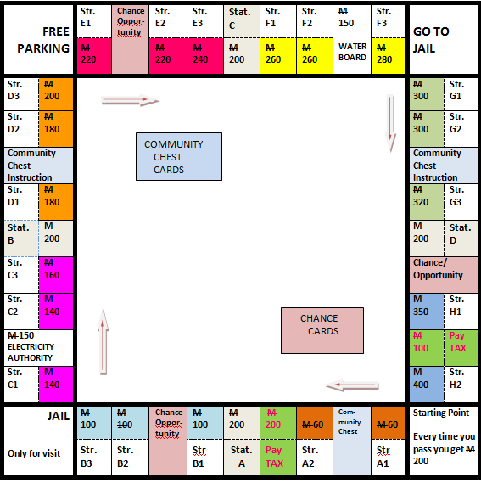In order to develop lessons through the exploitation of the Monopoly game it is expected to use the Equipment for the game plus supporting material that provides supplementary illustrations that will help the students in developing their mathematical skills. You need the following:

## Board

**4 cells at the corners :** the Starting Point, the Jail (either for imprisoning or for visiting), the Parking Place and the Point Sending to Jail

**28 cells at the edge for the properties**: 22 of them representing plots in 22 different streets and corresponding to 8 colors, 4 cells representing plots where rail stations are based and 2 cells representing plots where services are stationed (one for the Water Board and the other for the Electricity Authority)

**6 cells at the edge** representing (the 3 of them) Chance/Opportunity points and (the other 3) Community chest points

**2 cells at the edge for** imposition of Taxes

**2 Rectangles in the inner part** for placing the Chance and the Community Chest Cards

## Cards

Given are the 16 Community chest cards and the 16 chance cards, which look like left!

Go over each of them and read the information provided. What positive outcomes or what negative implications can you identify on each of them concerning your assets (money, properties, houses or hotels)?

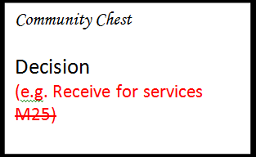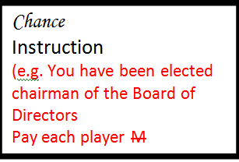

Consider the Title deeds for the various properties (totally 28) and go over the information written on them e.g. titles like the following:

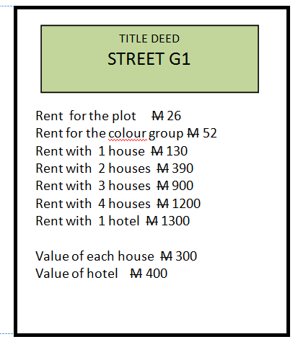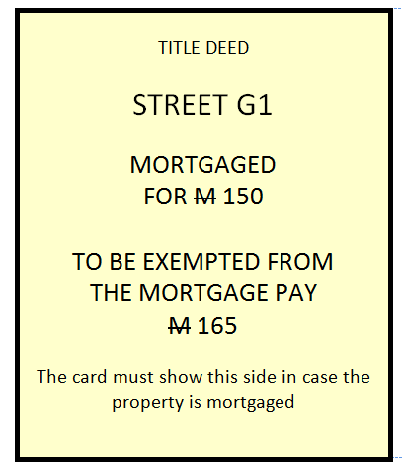

## Game Money

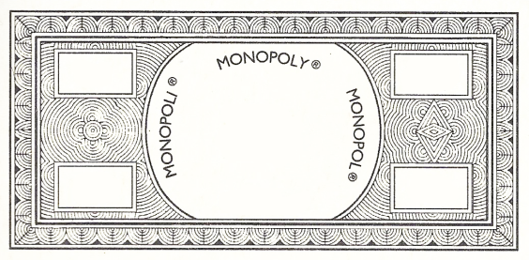

**100**



**10**

An amount of Money ~~M~~ of the following denominations

for each player:

2 × ~~M~~ 500

3 × ~~M~~ 100

2 × ~~M~~ 50

2 × ~~M~~ 20

6 × ~~M~~ 10

6 × ~~M~~ 5

5 × ~~M~~ 1

## Game Material

|  |  |
| --- | --- |
| 2 dice  Up to 8 tokens (one for each player to identify his/hers position on the Board)  32 images of houses  12 images of hotels  16 Chance cards  16 community chest cards  28 Title Deed cards (one for each property, on the right you see the front and the back of one card) | C:\Users\User\AppData\Local\Microsoft\Windows\Temporary Internet Files\Content.IE5\C4BE2RVB\dice-white[1].png  C:\Users\User\AppData\Local\Microsoft\Windows\Temporary Internet Files\Content.IE5\NA1NH16F\game-player-piece[1].png  C:\Users\User\AppData\Local\Microsoft\Windows\Temporary Internet Files\Content.IE5\C4BE2RVB\14484-illustration-of-a-house-pv[1].png  C:\Users\User\AppData\Local\Microsoft\Windows\Temporary Internet Files\Content.IE5\C4BE2RVB\14484-illustration-of-a-house-pv[1].png |

## Information-Card 1: Description of the Game MONOPOLY

**OBJECT OF THE GAME**The Object of the game is to become the wealthiest player through buying, renting and selling property  
  
**RULES OF THE GAME**

1. Decide who is going to be the Banker. He can be one of the players or not. Initially he holds all the money in a box (the BANK) as well as the cards with the Titles of the Deeds for all the Properties. As Banker he is responsible (a) to give an initial/ starting amount to each player, (b) To collect the taxes and deposit them in the Bank (c) to conduct auctions or other activities according to the instructions on the various cards (d) to manage mortgages (e) to sell the various properties (initially all belong to the Bank)
2. Decide on who is going to play first, second and so on by throwing the two dice and observing the total outcome. The highest is first and so on.
3. The Banker gives to each player an amount of ~~M~~ 1500. Furthermore each player is entitled (except if he is in jail) to a salary of ~~M~~ 200 each time he passes through the starting cell.
4. The game starts. Each player throws the two dice and counting from the starting point he moves clockwise to the cell shown by the outcome (sum of the outcomes on the two dice). Then, according to what the cell suggests the proper action is taken.
5. Each player takes turn throwing the dice and the game continues.
6. According to the cell reached each time the following activities take place: (a) Buying properties,
7. (b) Paying rent or tax, (c) Selling properties, (d) Exchanging properties, (e) Building houses, or Hotels (e) Take part in auctions (f) Mortgaging properties (g) Paying loans (h) whatever else is determined by the instructions either on the cards or on the Board
8. The points identifying the rules for particular activities or entities involved in the game as shown on Card 2
9. The game ends when only one of the players still has money and all the others have gone bankrupt

## Information-Card 2: Rules for Activities

|  |  |
| --- | --- |
| The bank | Holds the money, the Title Deeds for the properties and it is the owner of the houses and hotels prior to the purchase by the players  Collects taxes, fines, loans, interest and any other rights have to be paid to it or to the authorities. Conducts auctions. |
| Community Chest Cards and chance cards | After well shuffling are kept reversed down and placed in the appropriate cells in the centre of the Board. A player reaching an appropriate cell picks up the upper one and carries out the decision or instruction written on it. Then he puts it at the bottom of the pile of such cards in the appropriate cell. |
| Buying Property | When arriving at a cell, corresponding to property, the player can buy the property from the Bank at the specified value and get the Title Deed. If the player does not want to buy the property, the Bank sells it through an auction to the highest bidder, including the one that has just landed at the cell |
| Selling Property | Unimproved properties (plots without buildings), utilities and railway stations, may be sold privately to any player for any amount the owner can get. No property can be sold if buildings are standing in any other property of the same colour group. Houses and Hotels may be sold back to the Bank for half the price paid for them. |
| Paying/ getting rent | When arriving at a property belonging to another player, the owner is entitled to get rent as specified on the deed card. If the property is mortgaged no rent can be collected. In case the owner holds all the deed cards in the same colour, he can ask for double rent for unimproved properties in that colour, provided this colour group is not mortgaged. |
| Mortgages | Unimproved properties can be mortgaged through the Bank at any time. Before this all the buildings in that property must be sold to the Bank at half price.  In order to lift the mortgage the player must pay the Bank the amount for it plus 10%.  The owner may sell a mortgaged property to another player at any agreed price, with the buyer having the obligation to pay to the Bank 10% interest. |
| Jail | If you are in jail, you cannot collect the salary.  A player gets out of jail if (a) throwing a double in the next three turns, or (b) Using a card with an instruction to “Get Out” either by lifting it from the pile or by buying it from another player, or (c) by paying a fine of ~~M~~  100.  When in jail you are entitled to sell and buy properties. |
| Bankruptcy | This happens if a player owes more money than he can pay either to another player or to the Bank. In such a case this player retires from the game giving all his assets to the other player or to the Bank. For this the player returns to the Bank (in exchange of money) houses and hotels for half price. |

# Available Material in the Math-GAMES Project

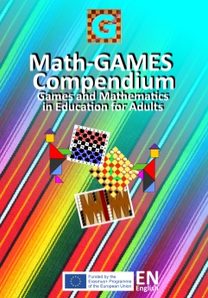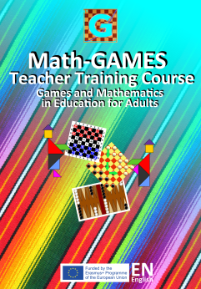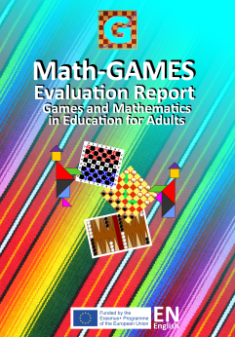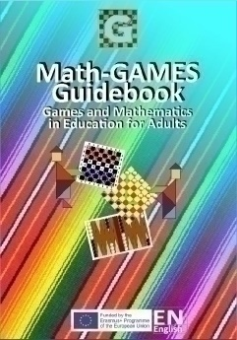

The four parts of the output of the project Math-GAMES:

* “**Math-GAMES Compendium of Famous Traditional Games**”, which are books in ten languages **(BG, DE, EN, ES, VA, FR, GR, IT, RO, TR)**. After that the partners of the project will prove how traditional games could be implemented in their learning program for a better understanding Mathematics, especially for lower skilled people, for young people and for immigrants, if there are needs.
* The results are the “**Math-GAMES Numeracy Learning Guidebook (Mathematical Literacy)**” in nine languages **(BG, DE, EN, ES, VA, FR, GR, IT, RO)**.
* In the third part of the project the project partners will prove by doing and testing during real courses and seminars that playing games between people with different skills assist in social integration and thus traditional games will be saved by transferring them to other people and they will not be lost. The result is a “**Math-GAMES Teacher Training Course and Seminar**”, which is held for the next years in different countries. The e-presentation, the seminar and the teacher-training course are published in English.
* Finally the “**Math-GAMES Testing and Evaluation Report**” will be published. It is a report about the project, the work, the activities during the lessons, the competitions in schools, the meetings and the evaluation. The Math-GAMES Project Report is published in English. All the Material is available from 2018.

**Information:**

Website: [www.math-games.eu](http://www.math-games.eu)

E-Mail: [roland.schneidt@web.de](mailto:roland.schneidt@web.de)

** Link to the special Math-GAMES YouTube Channel:**

[https://www.youtube.com/channel/UCvuYRVDPN WRNO5SwQiRre4](https://www.youtube.com/channel/UCvuYRVDPN%20WRNO5SwQiRre4)g

1. Prometheus was chained to a high rock as punishment because he brought salvation to man, by stealing the gods’ fire, but also by giving man numbers and their meaning. Thus, already 2,500 years ago, Aeschylus in his “Prometheus Bound” confirms the **importance of numbers for mankind**.

   <https://www.youtube.com/watch?v=kcWdcGwd844>